

COMSATS UNIVERSITY ISLAMABAD
COMPUTER VISION

Project Report

SUBMITTED BY:
Muhammad Ammar Rauf (FA23-BCS-059)
Muhammad Kaab Bhinder (FA23-BCS-068)
Syeda Rubab Zahra (FA23-BCS-096)
Submitted To:
Ma’am Maheen Gul

Lane Detection
1. Introduction
Lane detection is a key component in modern intelligent transportation systems. It plays a vital role in applications such as autonomous driving, driver assistance systems, and road safety analysis.
The goal of lane detection is to identify lane markings on roads from images or video streams. These lane markings guide vehicles to stay within safe driving boundaries.
In this project, we implemented a lane detection system using classical computer vision techniques such as edge detection, region masking, and Hough Transform.

2. Problem Statement
Manual driving errors often occur due to poor visibility, distractions, or unclear road markings. Detecting lanes automatically can:
- Assist drivers
- Reduce accidents
- Enable autonomous vehicle navigation
The problem is to detect lane lines accurately from road images under varying conditions.

3. Objectives
- Develop a lane detection pipeline using image processing
- Detect straight lane lines from road images
- Reduce noise and irrelevant details
- Highlight lane boundaries clearly
- Save processed output images

4. Literature Background
4.1 Image Processing
Image processing involves transforming an image into a more useful form. It includes:
- Filtering
- Edge detection
- Feature extraction

4.2 Edge Detection
Edges represent sudden intensity changes in images. Detecting edges helps identify boundaries like lane lines.
We use Canny Edge Detection, which includes:
- Noise reduction
- Gradient calculation
- Non-maximum suppression
- Double thresholding

4.3 Hough Transform
Hough Transform is used to detect shapes like lines in an image.
It works by:
- Converting points in image space → parameter space
- Finding intersections (votes)
- Detecting lines from peaks

4.4. Video Processing Functionality
In addition to processing static images, the system is capable of detecting lane lines in video streams. This is achieved by applying the lane detection pipeline to each frame of the video.
1. Working Principle
- A video is treated as a sequence of frames (images).
- Each frame is passed through the same pipeline:
  - Grayscale conversion
  - Gaussian blur
  - Canny edge detection
  - Region of Interest masking
  - Hough Transform
  - Lane line drawing
- The processed frames are then combined back to form an output video.

2. Implementation
- The MoviePy library is used for video handling.
- Function process_image() is applied to every frame.
Example workflow:
- Load video file
- Extract frames automatically
- Apply lane detection pipeline
- Write processed frames into output video
3. Input Videos
The system was tested on:
- solidWhiteRight.mp4
- solidYellowLeft.mp4
- challenge.mp4

4. Output
- Output videos show highlighted lane lines
- Lane boundaries are visible in real-time playback

5. System Architecture
The pipeline follows this structure:
Input Image
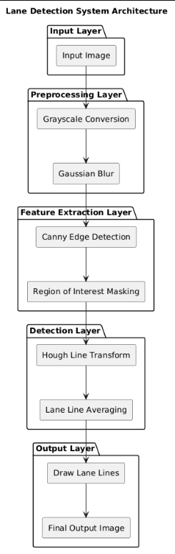

6. Methodology
6.1 Image Input
- Images are loaded from a dataset folder
- Stored as NumPy arrays

6.2 Grayscale Conversion
- RGB image → grayscale
- Formula reduces 3 channels into 1
Benefit:
- Faster processing
- Less computation

6.3 Gaussian Blur
- Smoothens the image
- Removes high-frequency noise
Kernel size is important (e.g., 5x5)

6.4 Canny Edge Detection
- Detects strong edges
- Uses thresholds:
  - Lower threshold
  - Upper threshold
Output:
Binary image showing edges

6.5 Region of Interest (ROI)
- Define polygon mask (triangle/trapezoid)
- Keep only road region
Removes:
- Sky
- Buildings
- Trees

6.6 Hough Line Transform
- Detect lines from edge points
- Parameters:
  - rho (distance resolution)
  - theta (angle resolution)
  - threshold (minimum votes)
Output:
Set of detected lines

6.7 Line Averaging
- Separate left and right lanes
- Average slopes
- Draw smooth lane lines

6.8 Overlay on Original Image
- Combine detected lines with original image
- Final output shows highlighted lanes

7. Implementation Details
Libraries Used
- cv2 → Image processing
- numpy → Array operations
- matplotlib → Visualization

Key Functions
- grayscale() → Convert image
- gaussian_blur() → Reduce noise
- canny() → Detect edges
- region_of_interest() → Mask image
- hough_lines() → Detect lines
- draw_lines() → Draw lanes

8. Results & Observations
Results
- Lane lines successfully detected
- Clear visualization on straight roads
- Output images stored properly
Observations
- Works best in:
  - Good lighting
  - Clear lane markings
- Performance drops in:
  - Night conditions
  - Curved roads
  - Shadows

9. Performance Analysis
Factor | Effect
Lighting | High impact
Noise | Medium
Road curvature | High
Image resolution | Low

10. Advantages
- Simple and easy to implement
- Fast processing
- No training data required
- Works well for structured roads

11. Limitations
- Cannot handle curved lanes well
- Sensitive to lighting changes
- Fails in complex environments
- Not suitable for real-world autonomous driving alone

12. Applications
- Self-driving cars
- Driver assistance systems
- Traffic monitoring
- Road safety analysis

13. Future Enhancements
- Use Deep Learning (CNN, YOLO)
- Lane curvature detection
- Shadow and illumination handling
- Integration with sensors (LiDAR, GPS)

14. Conclusion
This project demonstrates how classical computer vision techniques can be used to detect lane lines effectively. While the system works well in controlled conditions, improvements are needed for real-world deployment.

